https://www.youtube.com/watch?v=nta8uyl1_E0
Nuget Package : MongoDB.Driver

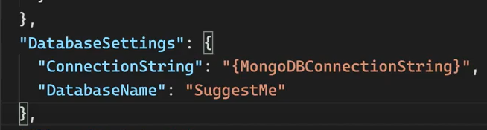

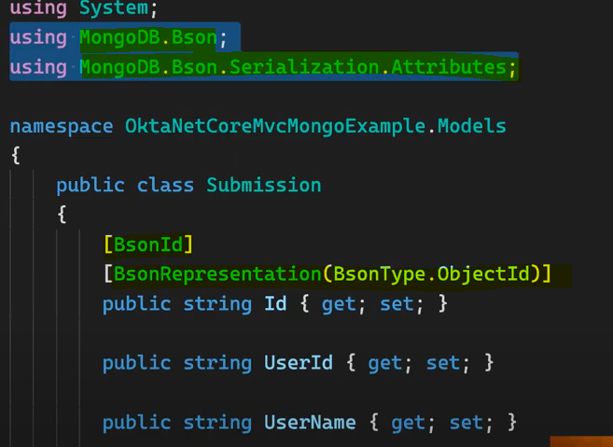

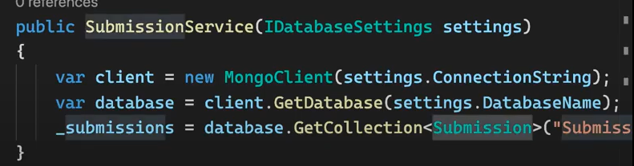

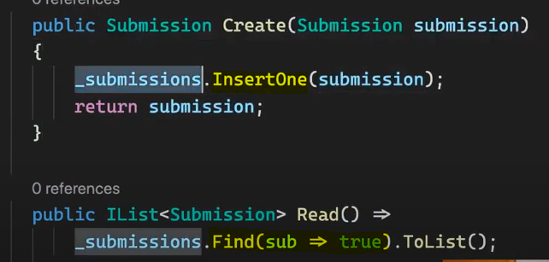

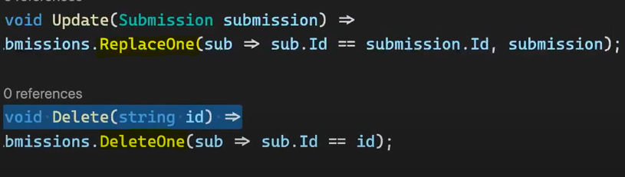

https://www.c-sharpcorner.com/article/using-mongodb-with-asp-net-core-web-api/

https://codewithmukesh.com/blog/mongodb-in-aspnet-core/

